GRAPH
/PIE=SUM(Rock1_gravel) SUM(Rock1_sand) SUM(Rock1_water)
/PANEL COLVAR=Stygobromus COLOP=CROSS
/MISSING=LISTWISE.

Graph

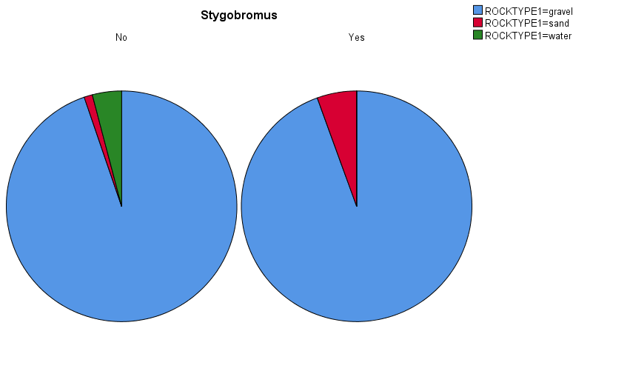

GRAPH
/PIE=SUM(Rock1_gravel) SUM(Rock1_sand) SUM(Rock1_water)
/PANEL COLVAR=Crangonyx COLOP=CROSS
/MISSING=LISTWISE.

Graph

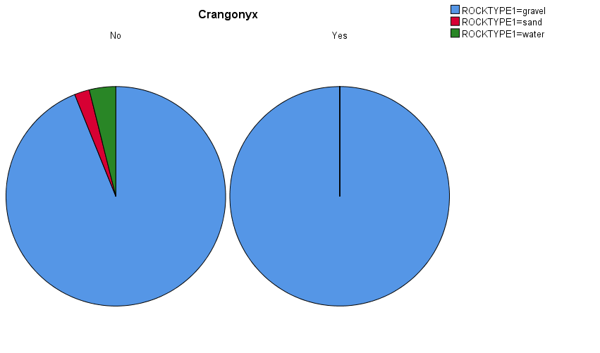

GRAPH
/PIE=SUM(Rock1_gravel) SUM(Rock1_sand) SUM(Rock1_water)
/PANEL COLVAR=Bin_inhabited COLOP=CROSS
/MISSING=LISTWISE.

Graph

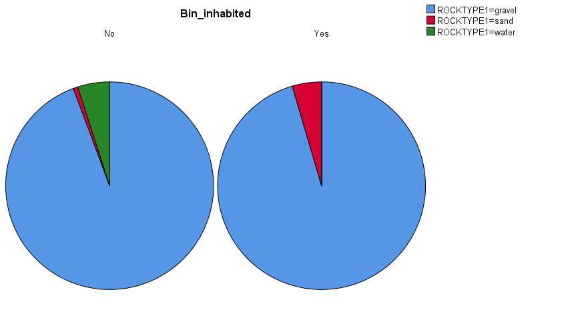

GRAPH
/PIE=SUM(Rock1_gravel) SUM(Rock1_sand) SUM(Rock1_water)
/PANEL COLVAR=Bin_hotspot COLOP=CROSS
/MISSING=LISTWISE.

Graph

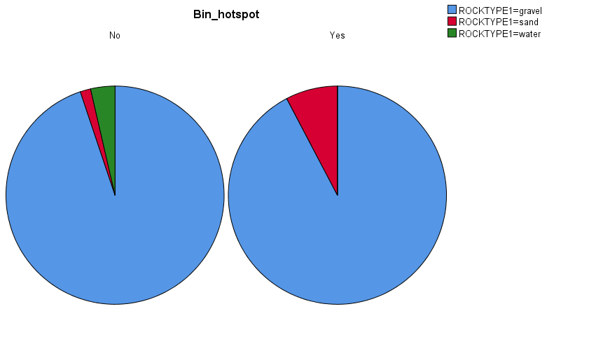

GRAPH
/PIE=SUM(Rock2_none) SUM(Rock2_clayormud) SUM(Rock2_sand)
/PANEL COLVAR=Bin_inhabited COLOP=CROSS
/MISSING=LISTWISE.

Graph

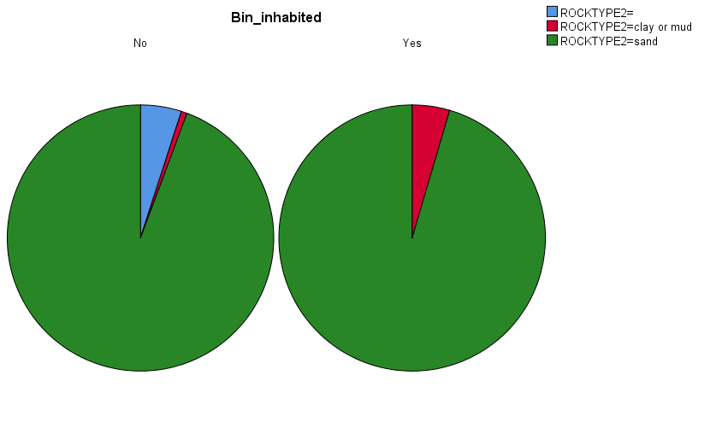

GRAPH
/PIE=SUM(Rock2_none) SUM(Rock2_clayormud) SUM(Rock2_sand)
/PANEL COLVAR=Bin_hotspot COLOP=CROSS
/MISSING=LISTWISE.

Graph

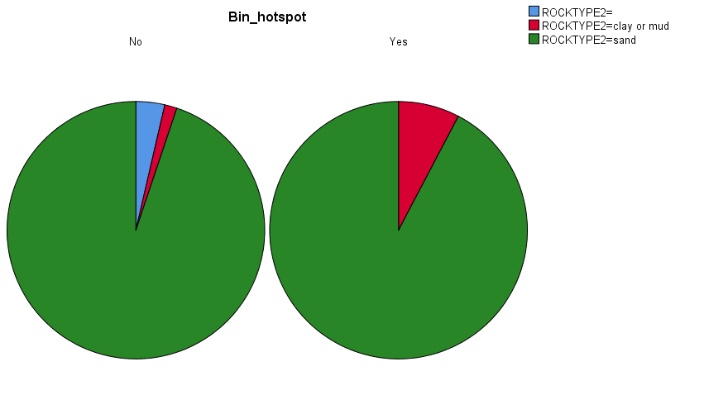

GRAPH
/PIE=SUM(Rock2_none) SUM(Rock2_clayormud) SUM(Rock2_sand)
/PANEL COLVAR=Stygobromus COLOP=CROSS
/MISSING=LISTWISE.

Graph

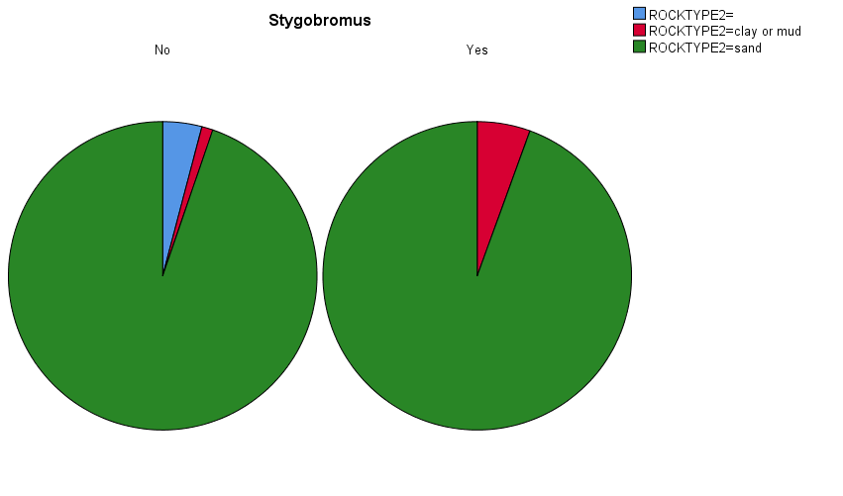

GRAPH
/PIE=SUM(Rock2_none) SUM(Rock2_clayormud) SUM(Rock2_sand)
/PANEL COLVAR=Crangonyx COLOP=CROSS
/MISSING=LISTWISE.

Graph

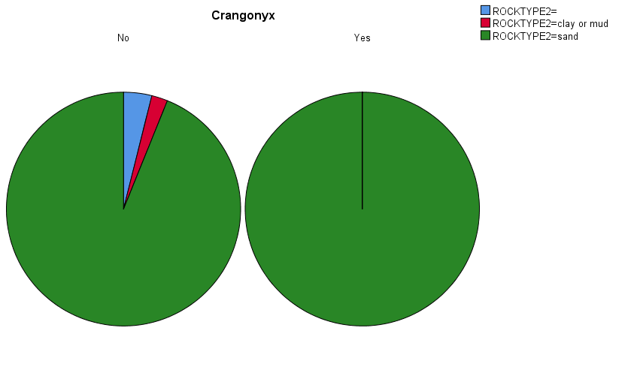

GRAPH
/PIE=SUM(Is_Calvert) SUM(Is_Upland) SUM(Is_Water) SUM(Is_Potomac) SUM(Is_Lowland)
/PANEL COLVAR=Bin_inhabited COLOP=CROSS
/MISSING=LISTWISE.

Graph

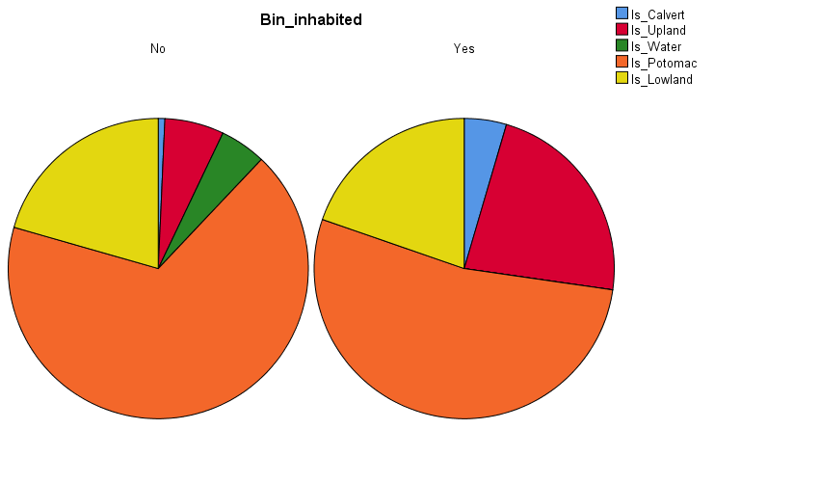

GRAPH
/PIE=SUM(Is_Calvert) SUM(Is_Upland) SUM(Is_Water) SUM(Is_Potomac) SUM(Is_Lowland)
/PANEL COLVAR=Bin_hotspot COLOP=CROSS
/MISSING=LISTWISE.

Graph

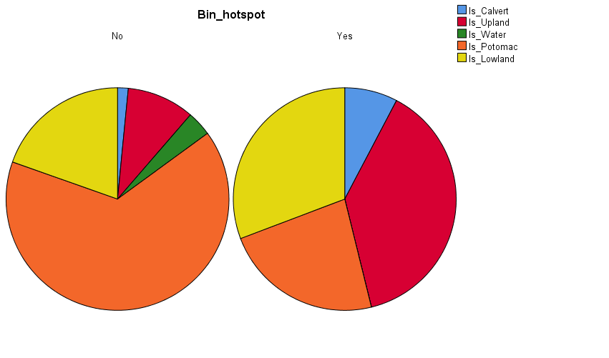

GRAPH
/PIE=SUM(Is_Calvert) SUM(Is_Upland) SUM(Is_Water) SUM(Is_Potomac) SUM(Is_Lowland)
/PANEL COLVAR=Stygobromus COLOP=CROSS
/MISSING=LISTWISE.

Graph

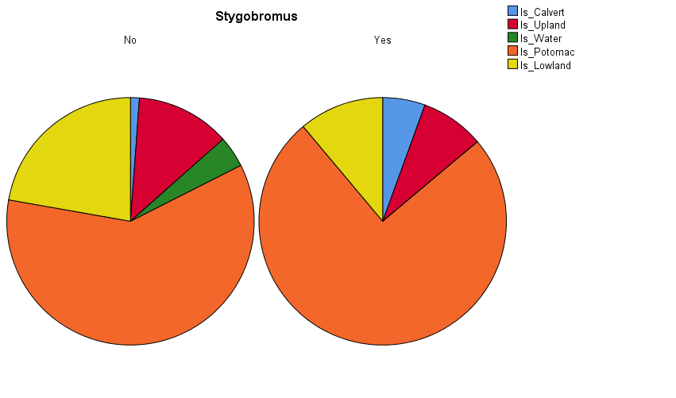

GRAPH
/PIE=SUM(Is_Calvert) SUM(Is_Upland) SUM(Is_Water) SUM(Is_Potomac) SUM(Is_Lowland)
/PANEL COLVAR=Crangonyx COLOP=CROSS
/MISSING=LISTWISE.

Graph

